Numeral System Installation Guide

### PREPARED FOR

Financial Simplicity

### PREPARED BY

SHAILENDAR.S

OVERVIEW

The objective of this assignment was to implement a system which converts the number provided by the user into its western numeral format. For eg if the user inputs 1234.04 the system should return One thousand, two hundred and thirty-four point zero four

**Installation Steps:**

1. **Prerequisites:**
   1. Visual Studio 2017 IDE or higher
   2. MS SQL Management Studio
   3. IIS for .Net Framework 4.7 or higher
2. **Database Setup:**
   1. Execute the queries in your SQL Database:

The queries will be available in the git hub repositories in the below path of the project folder or from your downloaded code location “..\NumberSystem\NumberSystem\DBLayer\DBScripts.sql”

* 1. Change the Data base connection string in the Web.Config file:

Change the name of the Data Source to your SQL server instance in the web.config file. If you have a Sql authentication implemented the please add your username and password as well.

Connection String Sample

<add name="DBConn_SQL" connectionString="Data Source=<SQL Server Instance>; Integrated Security=true;Initial Catalog=MVC; uid=<YourUserName>; Password=<yourpassword>; " providerName="System.Data.SqlClient;Connection Timeout=60" />

Web.Config Path:

“..\NumberSystem\NumberSystem\web.config

1. **Launch App Locally without hosting:**
   1. Open Visual Studio 2017 with admin access.
   2. Open the solution “NumberSystem.sln” from the downloaded code.
   3. Build it once to check for any build errors
   4. Launch the application using IIS express.

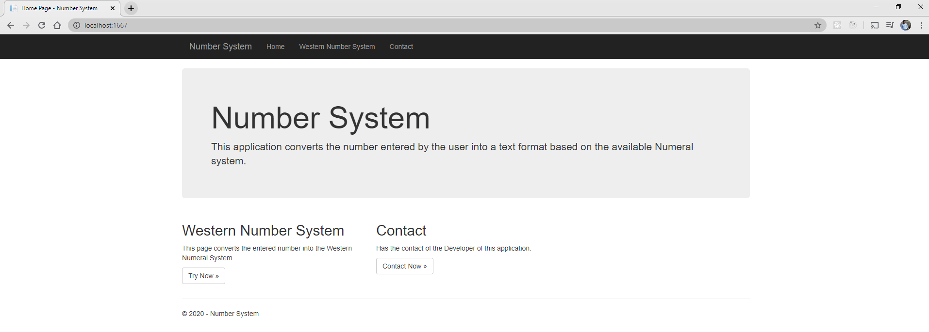

* 1. Navigate to Western Number System to play with the numbers.

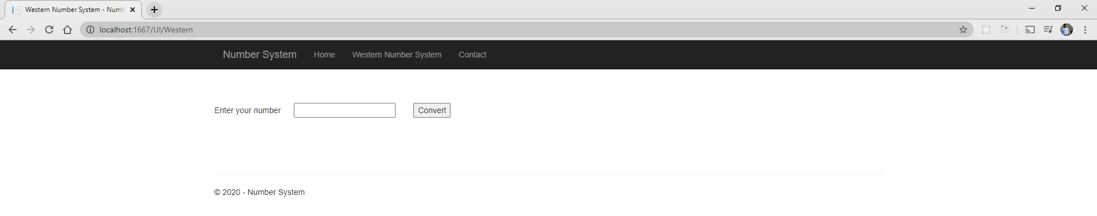

* 1. After the click of convert button. Click on save to save it to the database.

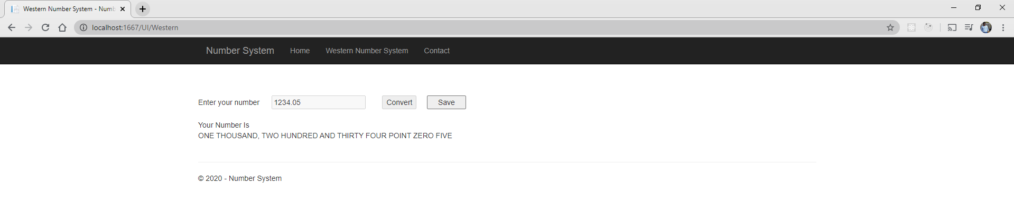

* 1. Run the below query in database to verify the save functionality.

SELECT [SlNo]

,[Number]

,[NumberText]

FROM [MVC].[dbo].[NumberData] order by slno

1. **Host the App from IIS**
   1. Right Click on the Project and click on Publish.

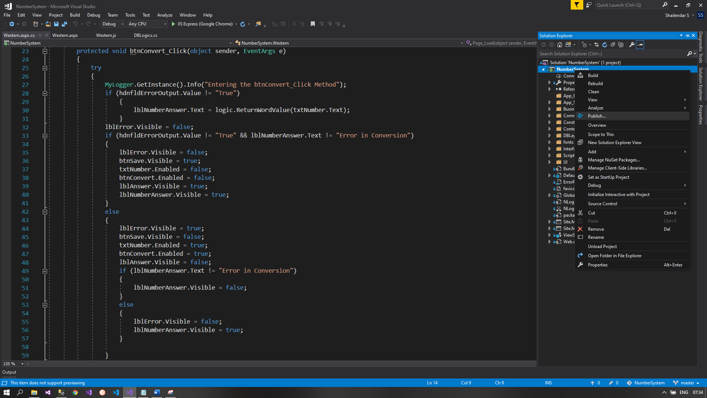

* 1. Select the publish target as folder.

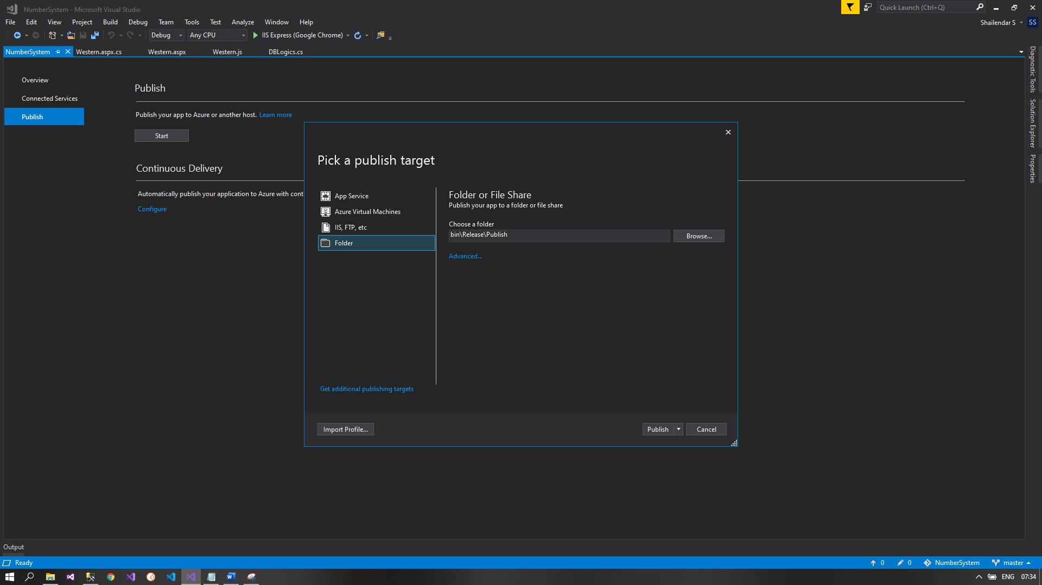

* 1. The files for deployment will be available at the below path of the project.

“/NumberSystem/NumberSystem/bin/Release/Publish”

* 1. Open IIS and create a website.

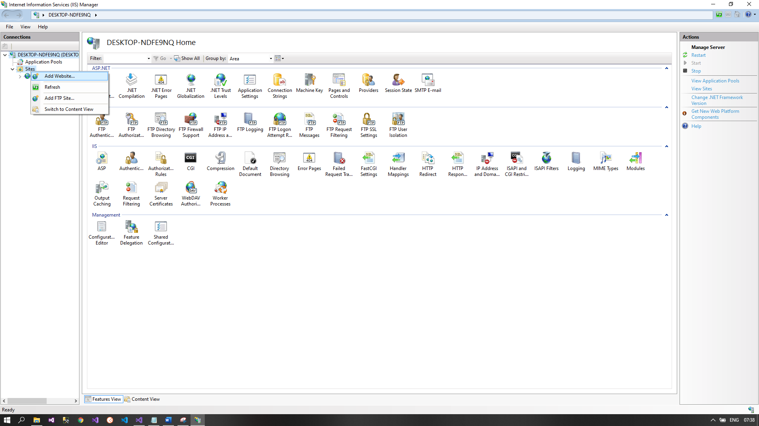

* 1. Select your preferred site name and location of the file deployment

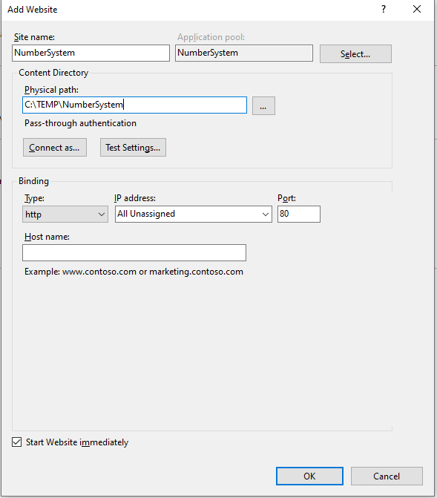

* 1. Copy the content from the Publish folder available at the below path to the new created path of the website.

“/NumberSystem/NumberSystem/bin/Release/Publish”

* 1. Create a Virtual Directory for the same.
  2. To connect to your DB from IIS please ensure that have necessary service account created which has access to Database. I changed the application pool identity to LocalSystem to have the access to Database.